

**Alaska Indoor Gardening Curriculum**

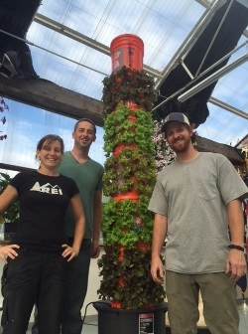

**Chena Hot Springs Growing Tower System**

**Directions**

The 'Do It Yourself' (DIY) Chena Grow Tower Project is the brainchild of Alaskan entrepreneur Bernie Karl and Jake Scott. It is much more than just an experiment with vertical hydroponics, it is a concept meant to spark the curiosity of the youth all over the country - To help sow the seeds that will yield the next generation of farmers and food suppliers in America.

In order to cultivate a genuine passion for food production, one must first be introduced to it in a hands-on manner. That is the true purpose of the Lettuce Tower Project - An easy-to-build project that can get our youth involved in the construction and use of a hydroponic food production system.

The Grow Tower can be built almost entirely with supplies from your local hardware store, it fits into a 4 ft2 space and produces around 14 heads of lettuce every week.

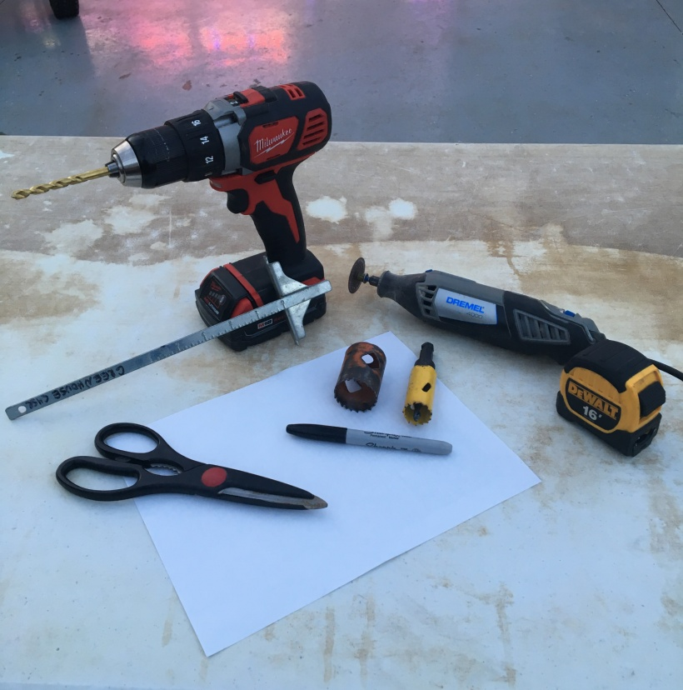**Tools Needed** (Fig. I)**:**

* Drill
* 1-5/8" Hole Saw Drill Bit
* Marker
* Dremel
* 7/8" Hole Saw Drill Bit
* Scrap Paper
* 1/4" Drill Bit
* Combination Square
* Scissors
* PVC Cement/Primer
* Ruler/Tape Measure
* Hot Glue Gun
* Protective Eyewear!

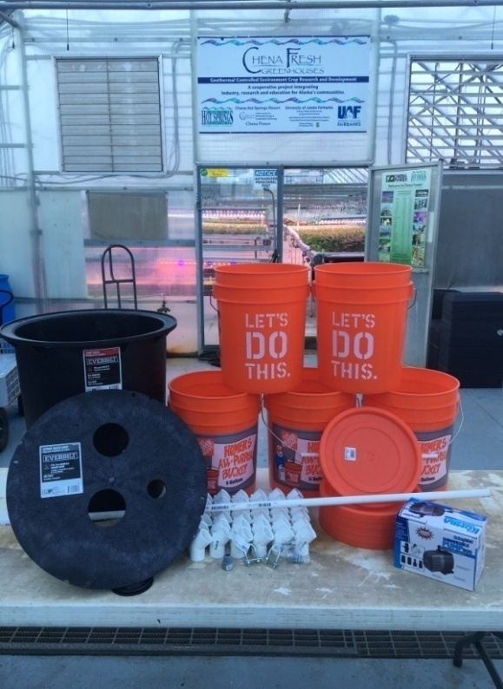**Materials Needed** (Fig. II)**:**

* 5-Gallon Buckets (x5)
* 1/4" x 1-1/8" x 2-1/16" U-Bolt (x2)
* 5-Gallon Bucket Easy Off Lids (x6)
* 1/4" Wing Nuts (x12)
* 1/2" PVC Pipe (6' 3")
* 18" x 22" Sump Pump Basin
* 1" 45° PVC Elbows (x72)
* 18" Solid Sump Basin Lid**\***
* 1/2" Threaded Male PVC Adapter**\***
* 396 GPH Submersible Water Pump**\***
* 1/4" x 1" Hex Bolts (x8)

**\* There are different types of sump basin lids. Be sure to get one with reinforced webbing on the bottom (often says sewer basin lid), as the single layer plastic lids will not support the weight of the tower. (see middle photo in step 2-1).**

**\* Be sure that the threads of your pump match those of your threaded male PVC adapter. We sourced our submersible pump from ECOPLUS through Amazon.com, but they are available at many local gardening centers. You need at least 350 GPH to get the water to the top of the tower. Larger GPH pumps will work fine, be slightly more expensive to run, and will be louder.**

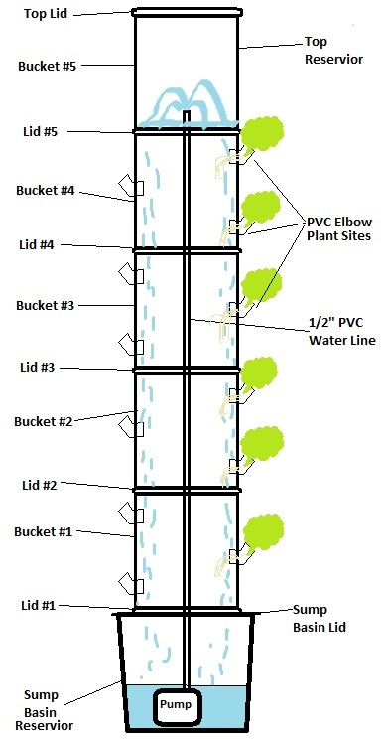

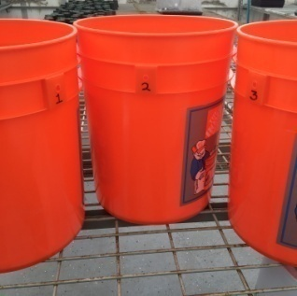**1-1: Remove the handles from all buckets and assign each bucket a number noting its position in the tower (i.e. #1 is the bottom bucket, #5 is the top bucket). *******Set aside #5…Don’t mark up this one!\*\*\*\*\*\*\*\***

**Stage 1: Creating the plant sites**

The bucket position numbers will be important to achieve alternating plant locations, or plant sites, from one bucket to the next.

Figure 1-a

**1-2: Create a template and mark the placement of the vertical lines on the lower 4 buckets. Do not mark lines on the top bucket as it will not have any plant sites.**

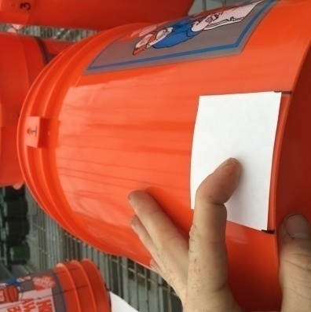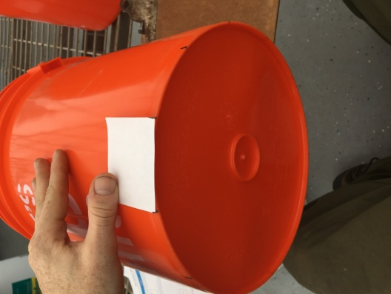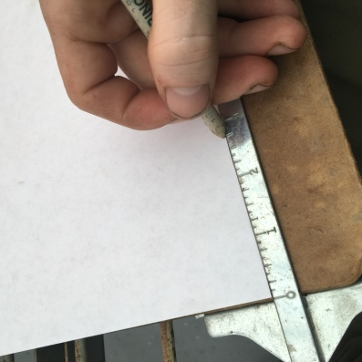

Figure 1-b

Figure 1-e

Figure 1-d

Figure 1-c

Center the template underneath one of the holes where the handle was attached. Make a mark as close to the bottom of the bucket on either side of the paper. Continue to slide the template over and make a mark until you have 12 equally spaced marks around the outside bottom of the bucket.

Make a template: Cut a square piece of paper that measures 2-3/4" on each side.

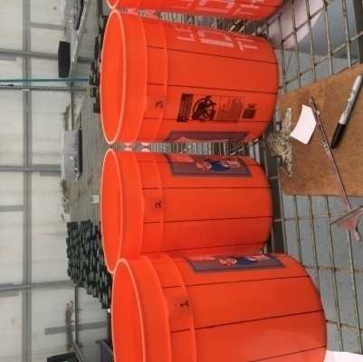**1-3: Use the combination square to create the vertical lines.**

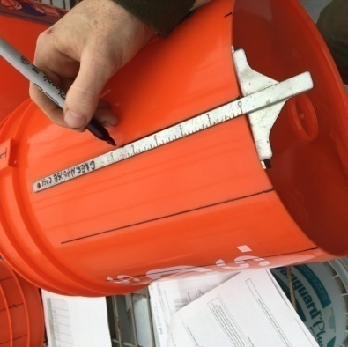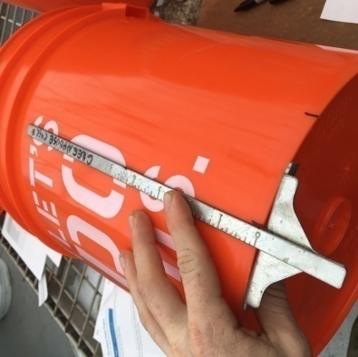

Figure 1-e

Figure 1-h

Figure 1-g

Figure 1-f

You should now have 12 equally spaced, vertical lines around the outside of 4 buckets.

**1-4: Measure and mark the locations of the plant sites on each vertical line.**

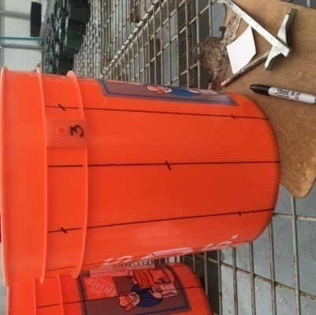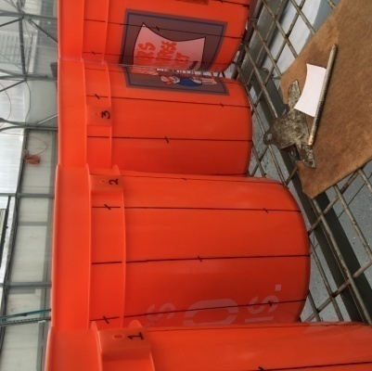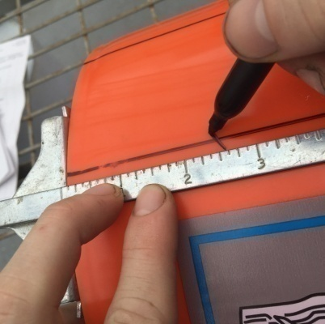

Figure 1-h

Figure 1-k

Figure 1-j

Figure 1-i

Each vertical line will alternate between having 1 or 2 plant sites. On the lines that have 2, the lower site will be 2.5" from the base of the bucket and the upper site will 2.5" from the top of the bucket. Lines with 1 site will be marked 7" from the base.

**1-5: Cut out the plant sites on all 4 buckets using the hole saw.**

**Stage 2: Creating the tower base**

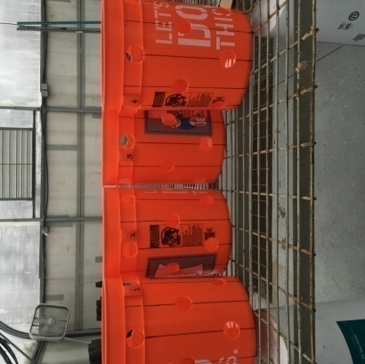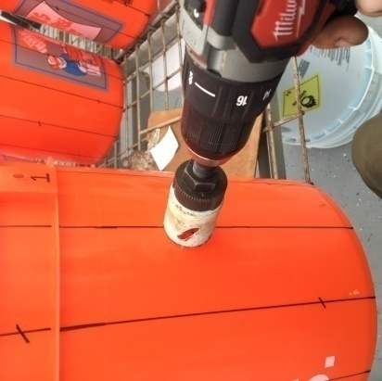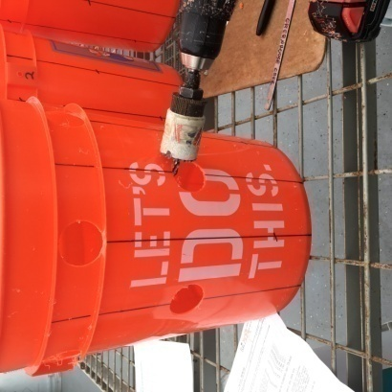

Figure 1-k

Figure 1-n

Figure 1-m

Figure 1-l

Using the 1-5/8" hole saw drill bit, cut out each plant site.

**2-1: Place a 5-gallon bucket lid in the center of the sump basin lid, drill holes and bolt them together.**

Figure 2-a

Figure 2-b

Figure 2-c

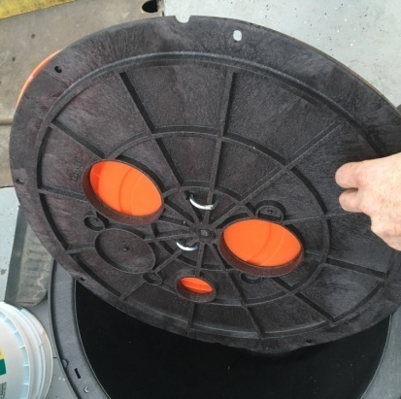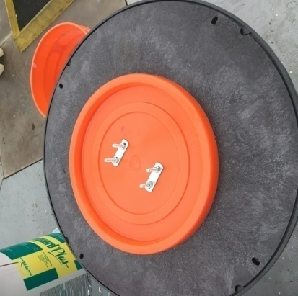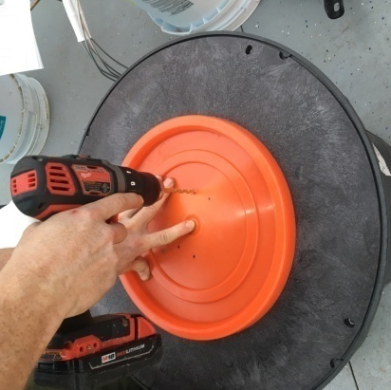

If it has them, be sure to cover any pre-cut holes in the basin lid with the 5-gal. lid. Using a drill with the 1/4" bit make holes through both lids for the 1/4" U-bolts. Mark the holes that are for the U-bolt so you don't get them mixed up with the drainage holes to be drilled in step 2-3.

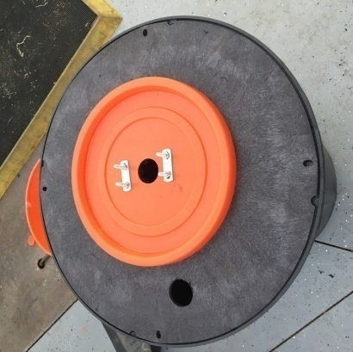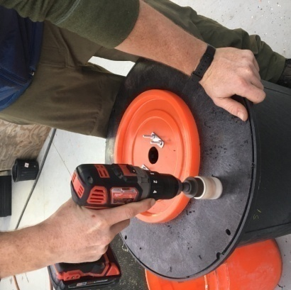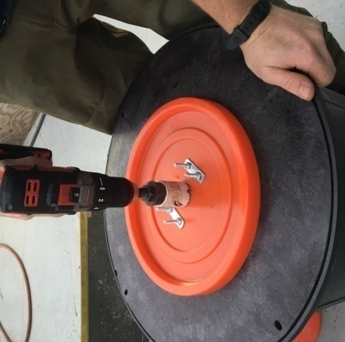**2-2: Cut holes for the water line and for reservoir maintenance.**

Figure 2-g

Using the 1-5/8" hole saw bit, make a hole as close to the center of the 5-gallon bucket lid. Cut through both the bucket lid and the basin lid. Next, make a hole somewhere on the outer 3" of the basin lid for the pump cord to run and to refill the tower with water and nutrients later on.

Figure 2-f

Figure 2-e

Figure 2-a

**2-3: Create drainage holes.**

Figure 2-d

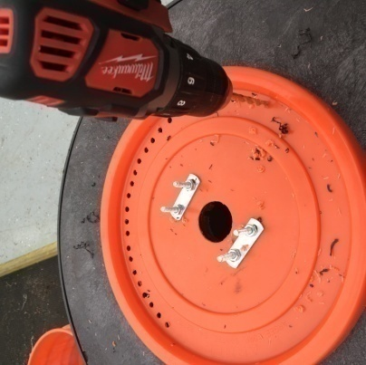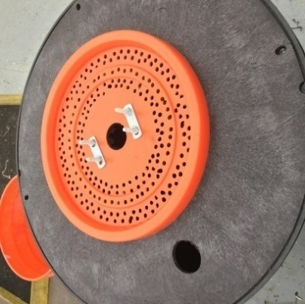

Figure 2-h

Figure 2-i

Using the 1/4" bit, drill several holes through both lids which will let the water fall back into the reservoir. For this particular lid, the more holes you have, the better.

**2-4: Remove the 5-gallon bucket lid from the basin lid and place it on the bottom of your designated bottom bucket. Drill holes in the bottom of the bottom bucket (Bucket #1) to line up with the U-bolts.**

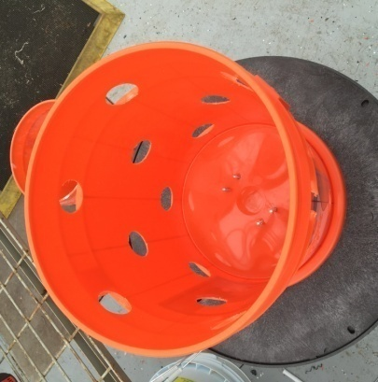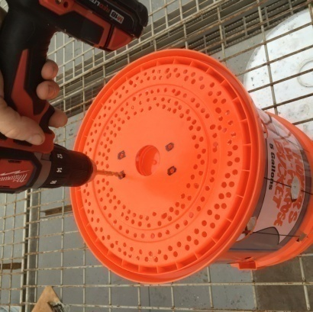

Figure 2-k

Figure 2-j

Using the 1/4" bit, drill holes in the bottom of bucket #1 to receive the U-bolts.

**2-5: Now cut a hole for the water line and then cut away all excess plastic from the bottom bucket that is not necessary to hold the bolts or the water line.**

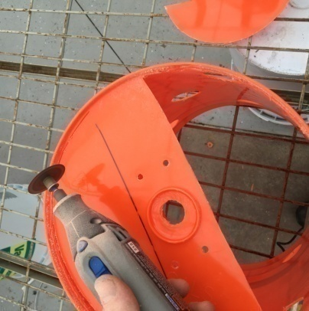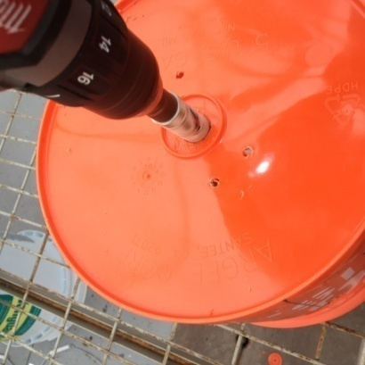

Figure 2-l

Figure 2-k

Using the 7/8" hole saw bit, cut a hole for the water line in the very center of the bottom of the bucket. Then, using the Dremel, cut away two large sections leaving just a strip of plastic with the 4 U-bolt holes and the center hole for the water line.

**2-6: Rinse away all the plastic debris with water and use the U-bolts to connect the bottom bucket to the bucket lid to the basin lid, in that order.**

**Stage 3: Creating drainage and attaching lids**

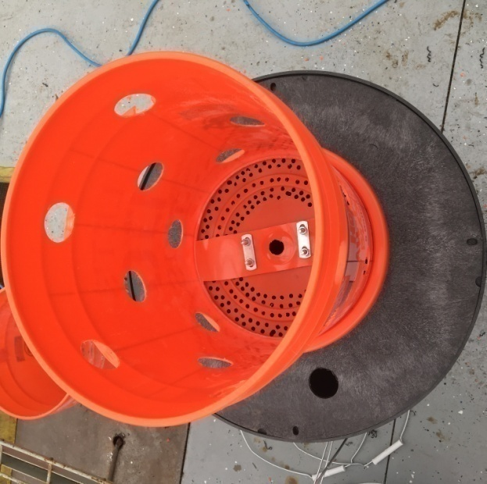

Figure 2-m

**3-1: Create drainage holes in 4 of the remaining bucket lids.**

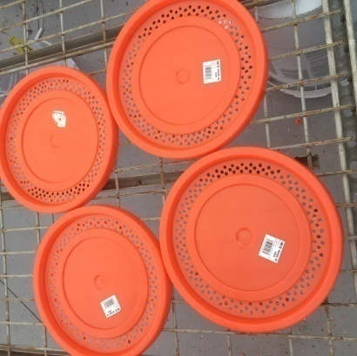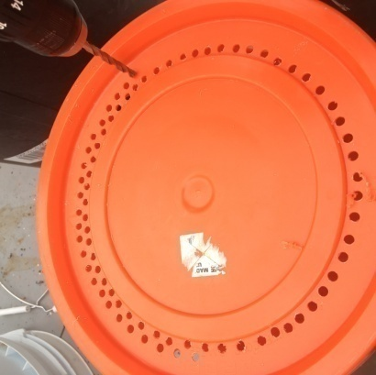

Figure 3-b

Figure 3-a

Using the 1/4" drill bit, create a showerhead type pattern of holes around the outer 2 inches of each lid.

**3-2: Cut holes for the water line in all of the remaining buckets and the center of *all but***

***one* of the bucket lids.**

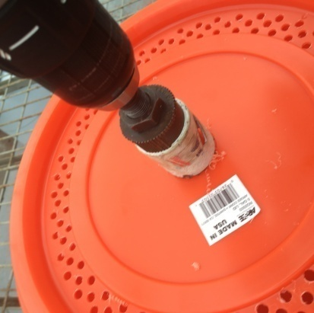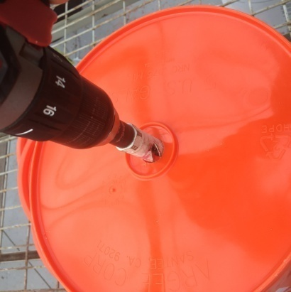

Figure 3-d

Figure 3-c

Using the 7/8" hole saw drill bit, cut a hole in the center of each lid except for the one that will be on the very top of the tower.

Using the 1-5/8" hole saw drill bit, cut a hole in the bottom center of each remaining bucket

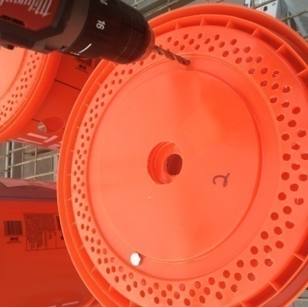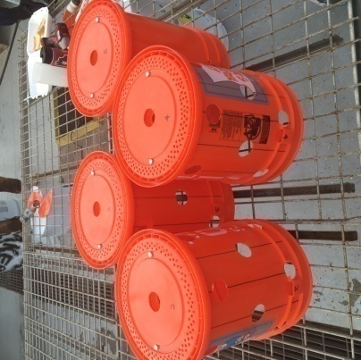**3-3: Create two symmetrical holes to bolt the lids to the buckets above them in the tower.**

Figure 3-f

Figure 3-e

Using the 1/4" drill bit, create two holes on opposite sides of the water line hole through both the lid and the bottom of each bucket to anchor each lid to the bottom of the bucket using the 1/4" x 1" hex bolts and wing nuts later. After you drill the holes, give each lid a number that corresponds with the bucket which it will be bolted to so you don't get them mixed up later.

**3-4: Similar to step 2-5, cut away two large sections from the bottom of each bucket.**

Figure 3-k

Figure 3-i

Figure 3-h

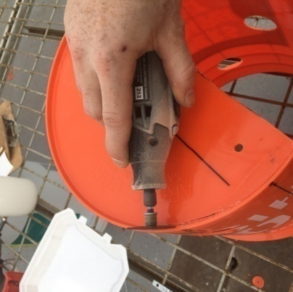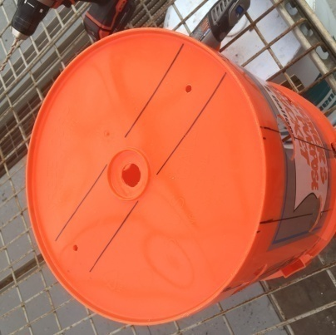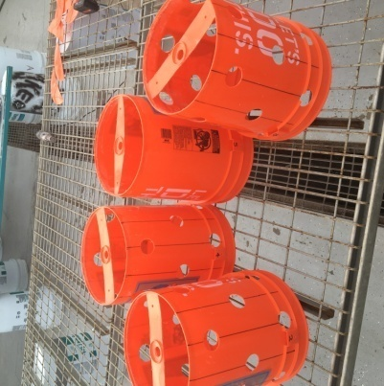

Using the Dremel, cut out two large sections from the bottom of the buckets leaving only a strip of plastic where the water line and bolt holes are situated.

Figure 3-g

**3-5: Rinse away all plastic debris and bolt each lid to the bottom of its respective bucket.**

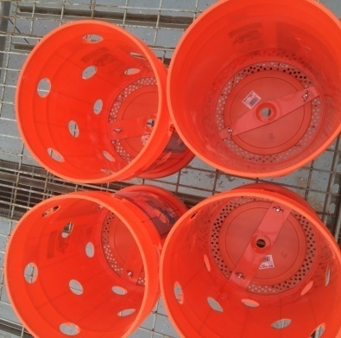

**Stage 4: Prepare and install plant site elbows**

Figure 3-k

**4-1: Drill 3 holes in the top of each PVC elbow as pictured below. Uniform placement of holes is not necessary as long as they are in a location that water falling from the top**

**of the tower can drip through.**

***Warning: Be sure to place the elbows in a vice or on a sturdy surface and keep fingers clear of the drill bit. This step is tedious, but also necessary to deliver water to young plant when they are first transplanted into the tower.***

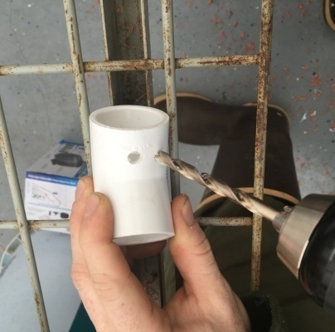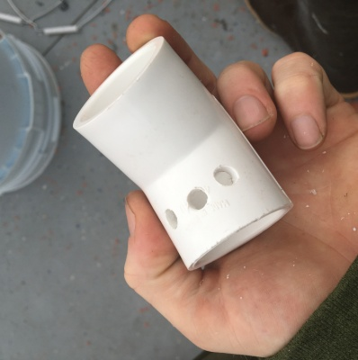

Figure 4-b

Figure 4-b

Figure 4-a

Using the 1/4" Drill Bit, drill three holes into the top of each PVC elbow to allow water to reach the plant roots. The holes should be positioned so that they are completely inside the tower when the elbow is inserted into the bucket. You can also add lengths of cotton twist string from the top of the tower through the elbows to aid the flow of water over the roots.

**4-2: After cleaning the plastic debris away, insert each elbow into each of the plant sites**

**that were created in step 1-5.**

Figure 4-e

Figure 4-d

Figure 4-c

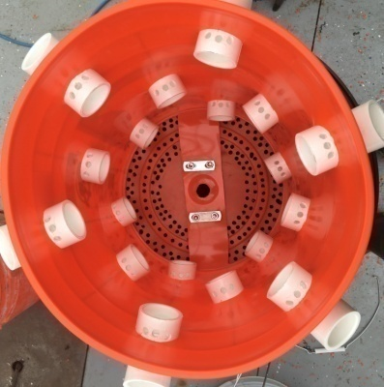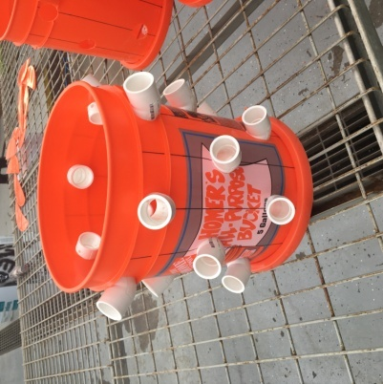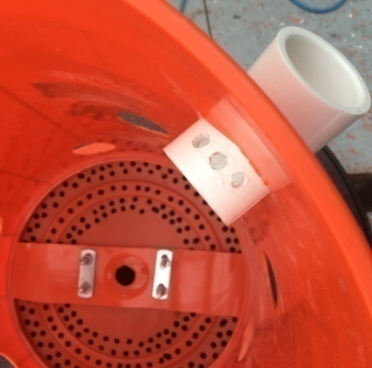

**4-3: Now it's time to fire up the glue gun. Use hot glue to create a seal around each elbow**

Figure 4-d

Figure 4-c

**to the bucket.**

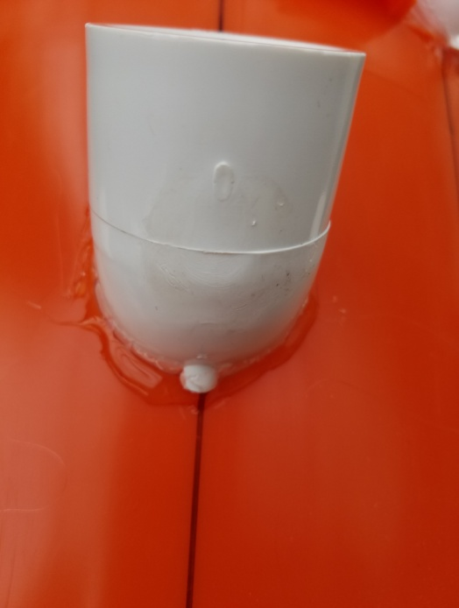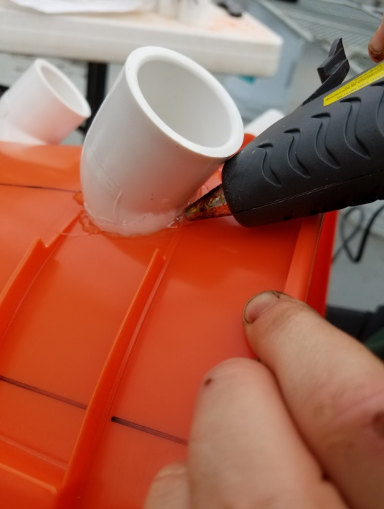

Figure 4-g

Be sure to create an even seal all the way around the elbows.

It will be a tight fit so be patient and do this step indoors or in a heated area to reduce the risk of cracking the buckets.

Figure 4-f

**Stage 5: Set up the water line and assemble the tower**

**5-1: Connect the threaded male PVC adapter to one end of the 1/2" PVC pipe.**

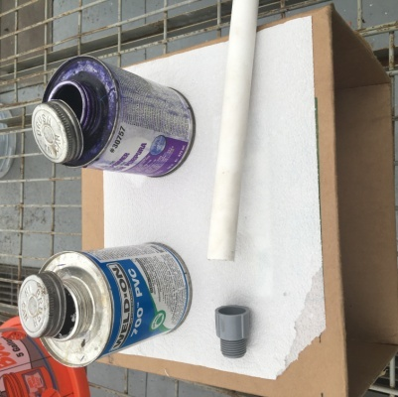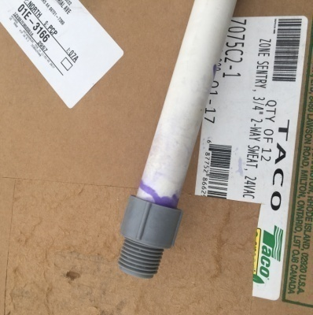

Figure 5-b

Figure 5-a

Be sure to use proper PVC primer and cement to ensure no leaks.

**5-2: Place the pump in the bottom of the sump basin and screw in the PVC pipe. Slide the tower base assembly down the pipe and feed the pump cord through the hole you drilled for it in step 2-2.**

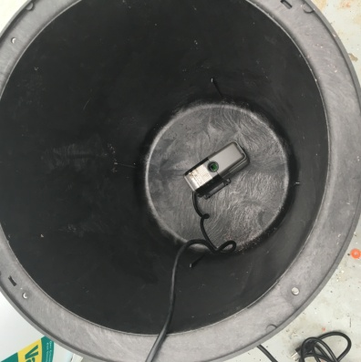

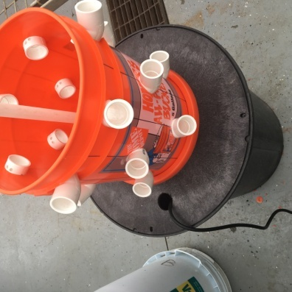

Figure 5-d

Figure 5-c

**5-3: Once the bucket base is snuggly in place, simply stack your buckets in the order that they are numbered and firmly snap each lid to the top of the next bucket. Be sure**

**that the top bucket has a lid on it as well.**

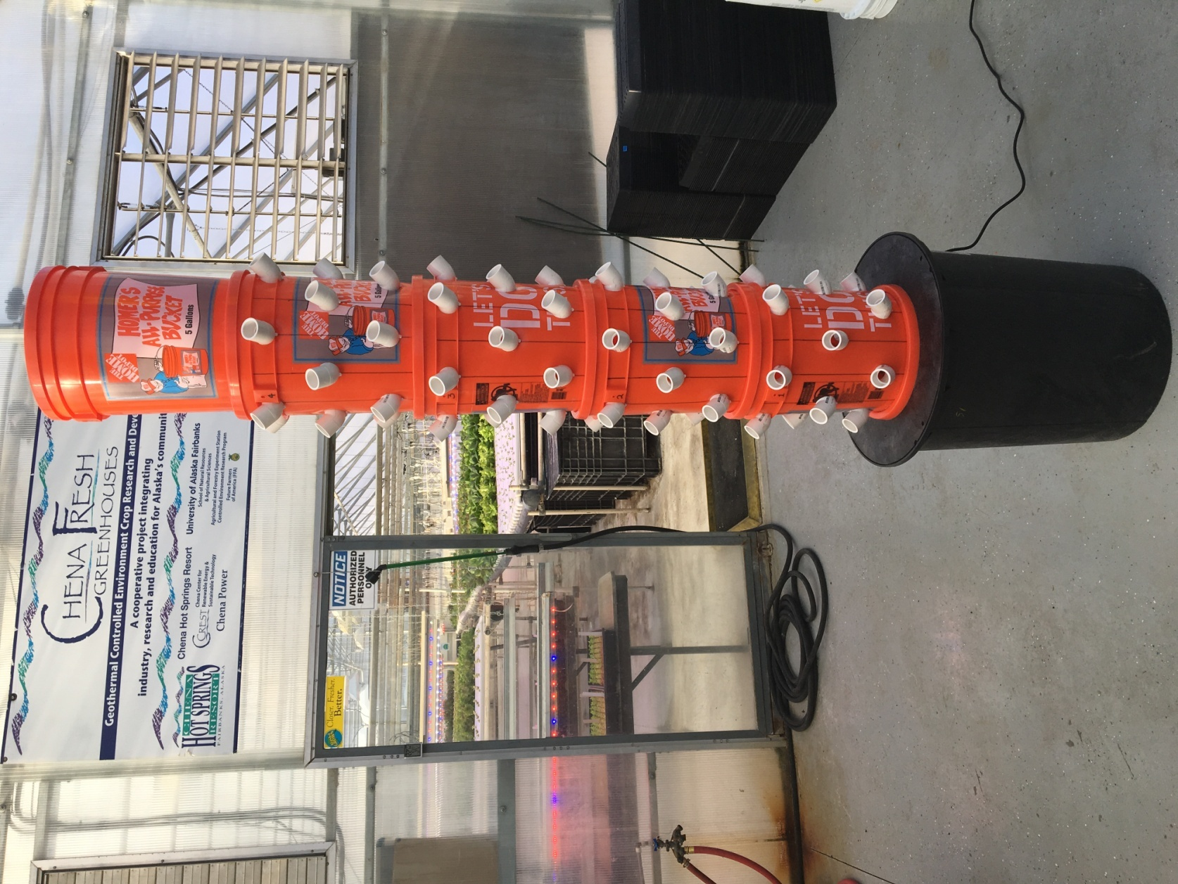

Part II:

How to Produce Results With Your Chena Grow Tower

So, you have built a brand new vertical grow tower with your own hands... *Now what?*

**Things to consider and choices to make:**

Crop Selection: The first choice to make is which crop you will grow in your tower as this will determine what type of fertilizer and potential lighting needed to get results. The Chena Grow Tower was originally created with the intention of growing lettuce and this choice may be the easiest for beginners, but the possibilities are much greater. The tower can produce spinach, arugula, mustard greens, strawberries, several herbs and many other options.

Fertilizer Selection: The fertilizer chosen should cater to the preference of the crop chosen (Lettuce is happy with something around 8-15-36). Some fertilizer brands such as *Chem-gro* from *Hydro-Gardens* or *The Urban Farm Fertilizer Company* have fertilizer products specifically designed for various crops. If you can't find a fertilizer specifically designed for your crop just take to the internet to find out what levels of N-P-K fertilizer are right for your plant and find a general use N-P-K fertilizer at your local home & garden store that is close to the levels your plant desires**. No matter what fertilizer product you choose, remember to always follow the mixing instructions on the bag for best results.**

Supplemental Light: Depending on where your tower is located and what you are growing in it, you may need some supplemental lighting to get the results you want. If you choose to grow lettuce or other leafy greens in your tower, your lighting requirements will be minimal and can be satisfied by using inexpensive CFL or LED light tubes and fixtures available at any home improvement store. If you decide to tackle a bigger challenge and produce a flowering/fruiting crop in your tower, then you may need to invest in some horticultural grade grow lights to achieve the best results. Always research your crop beforehand so you understand what your plants need.

**Supplemental Lighting Structure Suggestions:**

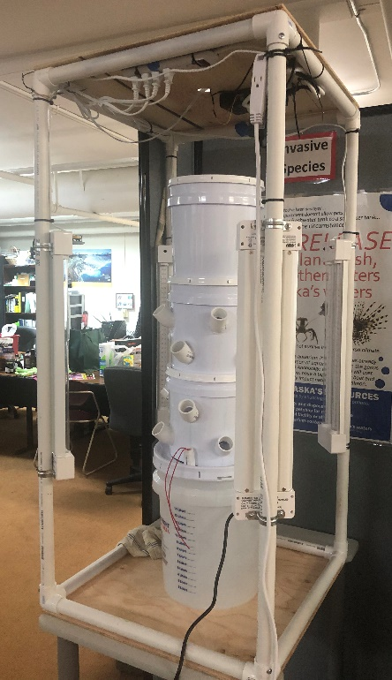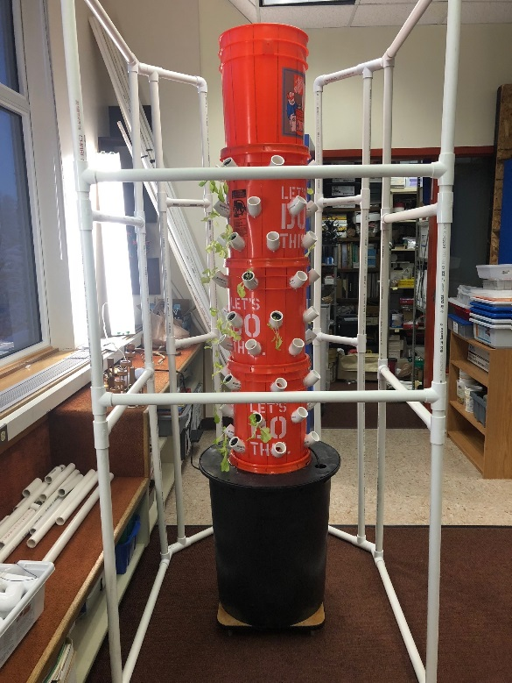

Using your Grow Tower:

* Start your seeds in a 98 count, 1.5" x 1.5" rockwool cube 2-3 weeks before you intend to put them into your grow tower. It is a good idea to start more seeds than will actually fit into your tower so may pick the strongest most promising seedlings to transplant into the tower. From planting the seed until transplanting into your tower, you may just water the rockwool cubes and seeds with regular, unfertilized water. The cubes should be watered daily and kept consistently moist throughout the plants life.
* About a week after your seedlings emerge begin checking the bottoms of the cubes daily. Once you can see little white roots starting to poke out of the bottom of the cubes your seedlings are ready to go into your tower.
* Prepare your tower by mixing the fertilizer of your choice according to the instructions on the fertilizer label and fill the base/reservoir of the tower with 10-15 gallons of this nutrient solution.
* Break your rockwool cube sheet into individual cubes with one plant per cube and simply stick them down in the PVC elbows/plant sites on the grow tower. Be sure to push the cube down far enough that it is securely nestled in the elbow underneath the three holes that you drilled but be sure not to push them too far and lose them inside the tower.

**Maintenance and Feeding Instructions:**

1. Monitor water levels and replace water, add nutrients to water before adding according to directions on container, as necessary. READ the directions, don’t over fertilize!!!!! It’s a good idea to reduce the fertilizer on water additions after the initial starting of the system to prevent nutrient buildup and overload.
2. Recheck pH and adjust with proper solutions if necessary.
3. Watch leaves for any browning or yellowing. This will let you know if you have enough or too much nutrient in your water.
4. Visit <https://www.youtube.com/watch?v=Webb1cjen6s> or <https://www.nosoilsolutions.com/common-issues-hydroponic-gardeners-face/> for suggestions on troubleshooting growing issues.

Nutrient Suggestions: Choose a liquid hydroponic nutrient based on your preference, organic or not. If you are just doing leafy greens, choose a nutrient specific to growing leaves often labeled “grow”. If you are doing a plant with fruit, you will need to change the nutrient once the plant reaches a certain maturity (different with each type), often labeled “bloom”, when you wish for them to begin the process of developing fruit. You will need to hand pollinate the plants.

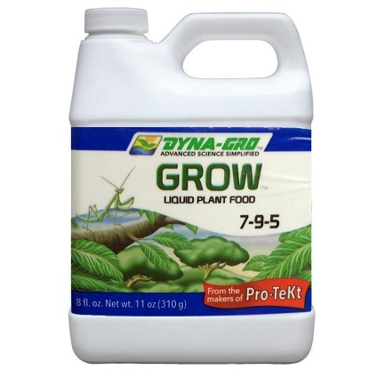

PH Testing – Use a test kit. A liquid test kit is preferable, but strips work as well. Use a solution to raise or lower the pH depending on results. Over fertilizing is often the cause of a wacky pH, but it can be the water you start with as well.

Algae growth is normal, not toxic or dangerous to the edibility of your plants. It can cause fungus gnats which can be a problem. Here is an article that might help you if you have an algae issue.

<https://plantprovider.com/managing-algae-in-hydroponic-systems-step-by-step/>

**References**

**Books:**

*Gardening Indoors with Soil and Hydroponics*

by George Van Patten 2007 ISBN: 978-1-878823-32-8

*How to Hydroponics*by Kenneth Roberto

ISBN: 0-9672026-1-2 2014

*Hydroponic Basics: The Basics of Soilless Gardening Indoors*

by*George F. Van Patton 2004 ISBN: 978-1-878823-25-0*

*Hydroponics: A Complete DIY Guide for Gardening Using Simple Steps*

by Allen Dunn 2012 ISBN: 9781480236141

*Vertical Gardening: Grow Up, Not Out, For More Vegetables and Flowers in Much Less Space*

by Derek Fell 2011 ISBN: 978-1-60529-083-6

*Vertical Gardening for Beginners: How to Grow Organic Food at Home Without a Yard*

*by*PeterKingston 2016 ISBN: 9781532804823

**Websites:**

*Chena Hot Springs Resort:*<https://chenahotsprings.com/vertical-bucket-grow-tower/>

*Foothill Hydroponics:* <http://www.foothillhydroponics.com/>

*General Hydroponics:* <http://generalhydroponics.com/>

*Hydroponics:* <https://hydroponics.com/>

*Institute of Simplified Hydroponics:* <http://carbon.org/>

Simply Hydroponics and Organics: <http://www.simplyhydro.com/system.htm>

*Uponics***:** <http://uponics.com/hydroponic-tower/>